NEA Programming Project
Table of Contents
Analysis 2
Overview 2
Features Solvable by Computational Methods 3
Querying & Inserting Data 3
Iteration 3
Sorting 3
Features 4
Graphical User Interface 4
Database 4
Login System 4
Leaderboard 4
Inventory System 5
Chance Actions 5
Adaptive Rooms 5
Adaptive Map 5
Stakeholders 7
Internal 7
External 8
Similar Games 9
Zork 9
The Hobbit 11
Pokémon Red/Blue/Yellow (1999) 13
Limitations 15
Simple Commands 15
Simple GUI 15
Requires Java 15
Linear Storyline 15
Requirements 16
Development 16
Post-Development 17
Success Criteria 19
#1 - Functional GUI 19
#2 – Room descriptions 19
#3 – Good combat system 19

Analysis

Overview
Space is a classic-style text adventure game, written in Java. It consists of entering commands to perform actions within the game, while the world is continuously described by the program, who is the narrator. There will be loot and weapons to find, enemies to defeat, and puzzles to solve. There will be enemies of varying difficulty to battle against, and a final boss guarding the finish for the game.

Features Solvable by Computational Methods

Querying & Inserting Data
The program will have to query data from the database when logging into an account to check for matching data, and when displaying the leaderboard.
It will have to insert data into the database when creating a new account, and when saving players’ highest scores.

Iteration
After the game begins, the entirety of the code will be running through iteration, as it will be a constant loop of describing the world, and the player entering commands.
When executing certain commands (such as use, take, and examine), the program will use iteration to determine what items and/or entities the player is referencing by looping through everything in their inventory and in the room they’re currently in.

Sorting
When viewing the leaderboard, the game will use an insertion sort algorithm to retrieve a certain number of high scores and display them to the player in order of highest to lowest.
The player’s inventory will also utilise an insertion sort algorithm to put all items in order alphabetically.

Features

Graphical User Interface
The GUI for the game will be relatively simple. There will be the main chat box where the narrator will talk to the player, and the player will enter commands. At the top of the screen will be a single column constantly displaying the room the player is in, and the health of the player. In the top right corner, there will be a rectangular box displaying the player’s location relative to the map. When chance-based events occur, the map will be replaced with a dice roll animation, and then it will return to the map.

Database
Space will incorporate a MySQL database to store data globally for each user. The primary key will be the player’s unique username, stored as a string. There will also be a field for storing the player’s hashed password, also as a string. The final field will be for the player’s highest score, stored as an integer.

Login System
When the game first loads, there will be a login screen where the user can create/login to an account. When creating an account, the program will query the database to see if the username is available. If it is, the program will hash the password and store it with the username. When logging in, the program will hash the entered password and check it against the one stored in the database, and if they do not match, the user will not be able to log in.
When the game is launched, it will test the connection with the database. If the connection fails, the game will enter a guest mode, where the player can pick their name, but no data is saved.

Leaderboard
From the main menu, users will be able to access the global leaderboard. The program will query the database for all the players’ usernames and scores, and display a set amount of players’ top scores with their usernames. This will be inefficient if there is a large number of players, as it will discard the majority, but this should not be a problem in this project.
If I were to fix this, I would most likely use two tables: one to store the player data, and one to store the top n player usernames and scores. The table for the scores would then update once every hour, meaning the game would not have to process each user itself.

Inventory System
Throughout the game, there will be items the player can pick up. When they do, the item will be added to their inventory – a space where all their items are stored. At any point, players will be able to check their inventory, and also try to use items from it. Some items will be finite (such as food), meaning the quantity decreases when it is used. However, others will be infinite (such as swords) and will have unlimited uses.
When an item is added to the inventory, it will be sorted into an appropriate category (e.g. consumables, weapons), and then sorted alphabetically within their categories based on an insertion sort algorithm.

Chance Actions
In the game, there will be items and weapons that perform actions based upon chance, similar to the table-top game Dungeons & Dragons.
For example, there could be a sword that has a 25% chance to inflict a critical hit. This would require a roll of at least fifteen on a twenty-sided dice. When the player uses the sword, a dice rolling animation would play at the top of the GUI. If the roll was sufficient, the critical hit would be performed.
Other items that would utilise this could be potions, spells, armour, etc. It would also be utilised during attacks from enemies.

Adaptive Rooms
As the player moves between rooms, the narrator will describe them slightly differently depending on what the player has already done there. For example, if the player has already taken an item from a room, the program will remember and not tell the player about it next time. In addition, if a player has already defeated an enemy, the description will reflect this.

Adaptive Map
At the top of the GUI, there will be a small map of the world. At the beginning, this map will only show the room the player starts in, but will expand as they move around to reveal more. The map will be constructed from ASCII pipe characters, with each room taking up a predefined number of rows and columns.
To see if the player has explored a room, each Room object will have an “explored” Boolean value. If the value is true, then that room will be displayed on the map. There will also be numbers in each room, with a key on the side giving the names of the rooms.

Map Example
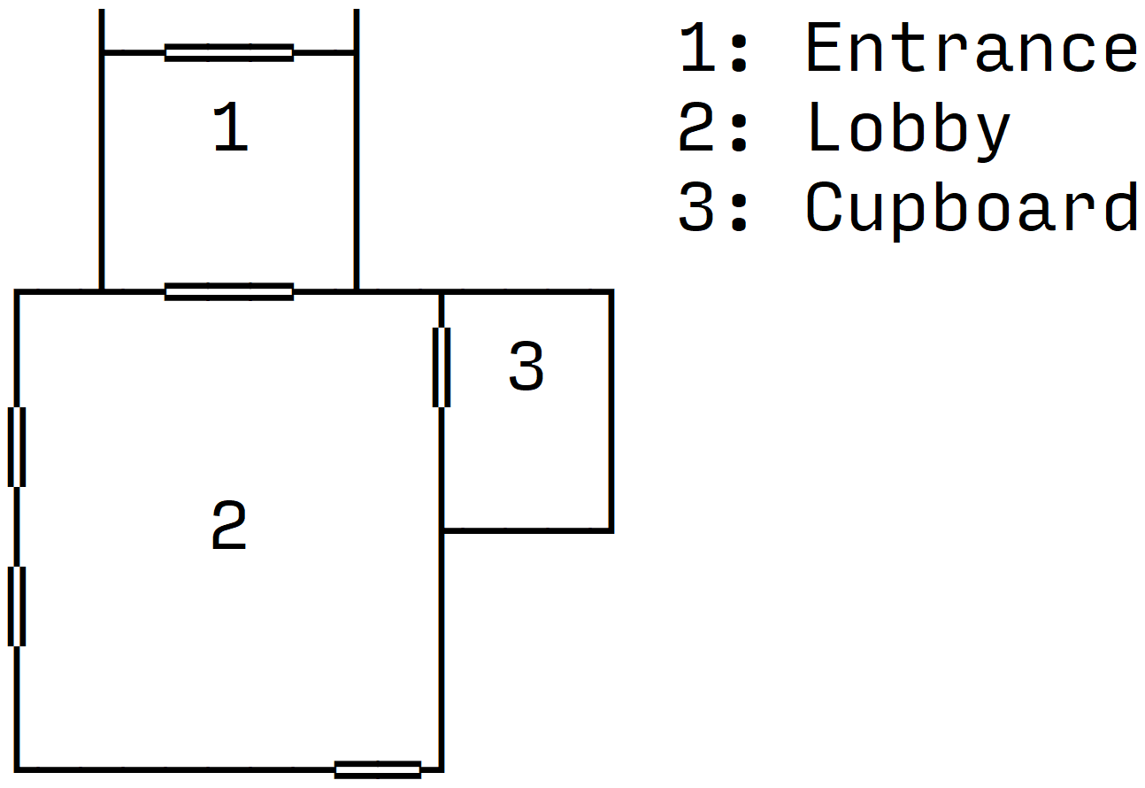

Symbol Key:
- Wall
  - │ ┌ ─ ┐ ├ ┤ ┼ └ ┘ ┬ ┴
- Door
  - ═ ║

Stakeholders

Internal

Developer (me)
I will be developing the game, and also playing it for testing.

Younger Players
Younger players are players aged under thirty-five. They will likely be playing as a large proportion of people in that age group play video games often.

Requirements
- Intuitive controls
Why: as younger players are unlikely to have come across text-based adventure games before, it’s important to make the controls (commands and parameters) easy to understand to prevent players from becoming frustrated and not wanting to play.
How: for each command, there will be a list of acceptable aliases (for example, to pick up an item, a player could either type “pickup”, or “take”, etc.). The game will also try to explain to the player what they typed wrong if there was a syntax error in their command.
- Challenging sections
Why: to prevent the player becoming bored, it’s important to have challenging sections. This is especially important for younger players as they will likely be used to modern games that often have very complex problems.
How: the game will contain challenging puzzles and enemies that are difficult to defeat.
- Fun combat system
Why: as younger players will likely be used to modern games such as first-person shooters, the game will need a combat system that is fun and will keep the player engaged.
How: the combat system needs to be a balance between challenging, easy to understand, and luck based. To accomplish this, it will undergo lots of testing with different people, and their views will be recorded, and the game adjusted to help. I will also take inspiration from popular games using a similar system, such as Pokémon.

Older Players
Older players are players aged thirty-five and over – this is due to the timeframe when text-based adventures were most popular, as they started to become less so towards 1990, so they are the ones likely to have played them as children. They will likely be playing due to nostalgia.

Requirements
- Classic look and feel
Why: as older players will most likely be playing due to nostalgia, it is important that the game will look and feel similar to those they would’ve played as children.
How: I will take inspiration from original text-based adventure games such as Zork and The Hobbit, incorporating key elements such as old-fashioned fonts and looking like a console.
- Engaging storyline
Why: as older players are typically more invested in the story of a game compared to younger players, it’s important to maintain its quality throughout the game to keep them engaged.
How: I will plan the entirety of the story out before hand and run it past a small selection of people that would be likely to play the game. I will them make adjustments according to their feedback.

External

PEGI
PEGI (Pan-European Game Information) is an organisation that rates games for age suitability based on their content. They will be playing to judge what ages the game is suitable for.

Requirements
- Follow the PEGI Code
Why: all games distributed within the EU must comply with the PEGI Code in order to receive a PEGI age rating. As these age ratings can be highly influential on whether people can play the game or not, it’s important the game complies.
How: the game will be in compliance with the applicable data protection and privacy laws. It will also not contain any monetisation methods.

Similar Games

Zork
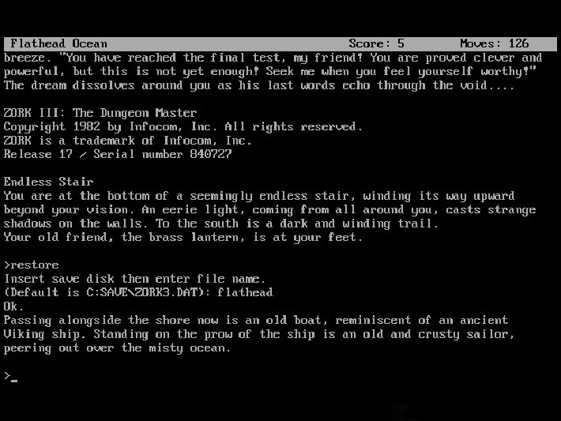
Zork is a text-based adventure game, released in 1977. It was extremely popular, and likely the most famous one to this date. In the game, the player explores the ruined Great Underground Empire and must complete puzzles and move around the map to proceed. To interact with the world, the player enters commands into a command line interface, the computer then responds to them, acting as the story’s narrator. The commands it accepts are very complex, allowing things like “north” and “get lamp”, but also “put the lamp and the sword in the case”.
It followed a linear storyline, meaning that all players would have to complete the same challenges in the same way, in the same order. The entirety of the first title took, on average, two and a half hours to complete.

Features

Complex Command System
The command system in Zork is very complex, allowing players to type commands in virtually plain English. This was very effective as it meant players didn’t have to read any instructions before playing. This makes the game extremely user-friendly and would’ve definitely helped the game in popularity when it was released.
I will not be incorporating this feature into my game, as I do not have the time available that it would take to implement. This will result in my game being less user-friendly, as players will likely have to review a list of commands at the start, so they know what is allowed. To mitigate the effect of this, I will be adding aliases for the commands – common alternatives for the keywords. For example, you could either type “take” or “pickup”, and they would perform the same action.

Simple GUI
The user interface in Zork is extremely simple, only being a command line. While this may not be as interesting to those used to modern video games, it keeps the code simple and allows the program to run very efficiently and consume minimal resources.
I will be incorporating this feature into my game, as I like the aesthetics of a classic command line interface, and I believe it could attract lots of older players towards my game due to their nostalgia for it. In addition to this, I do not think the time investment required to create images for each room would be worth it, as it would make it harder to add to the program later on.

Point System
Zork uses a point system to score players. You can get points for solving puzzles, acquiring treasures, performing certain actions, and visiting certain locations. This is useful because it allows the player to gauge how well they have played the game, and compare their score to other players and even compete to get the best one. This point system is not stored anywhere.
The game also keeps track of how many moves a player has taken – again something players can use to compare with friends and even perform speedruns on the game.
These are both features that I would like to incorporate into my game, because I feel like they’re very fun for the player to be able to see and compete with. However, I will be adding to these features by storing the number of points and moves for each player in a global database. These values will then be visible from the starting screen, along with the players’ usernames.

The Hobbit
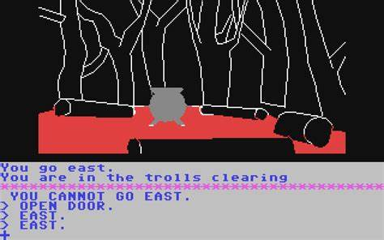
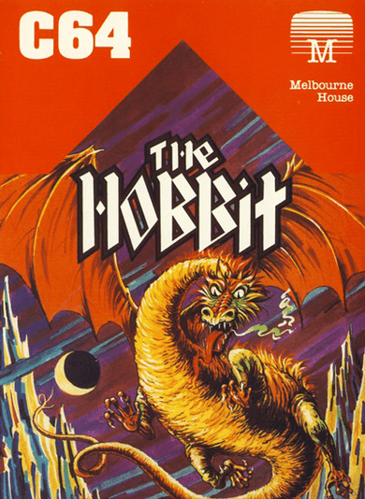
The Hobbit is a text-based adventure game, released in 1982. Like most adventure games of the time, it is made up of the player exploring the map, collecting treasures, fighting enemies, and solving puzzles. However, the reason this game was so successful was thanks to its illustrations. The majority of locations throughout the game had custom illustrations that the player could see. These were more detailed on the disk version, but simple outlines and filled colours on home computers to save space. These pictures allowed players to explore easily, and feel more engaged with the story.
In addition to this, it also used a very complex parser, using a subset of English called Inglish. This allowed players to type phrases such as “Ask Gandalf about the curious map then take the sword and kill the troll with it”. This made the game very appealing to players as it was so much easier than having to follow a rigid structure like other games.

Features

Illustrations
The Hobbit displays pictures for the vast majority of locations the player can be. This gives the player a much more detailed story to follow, feeling as if they are actually in the world itself. On the disk version of the game, it used detailed illustrations, but on the home computer versions, it used simple outlines that were filled by a solid colour, to save space.
While I would very much like to incorporate this feature, I will not be able to as I believe it is beyond my capabilities to create illustrations for all the map locations and still complete the program to an acceptable level. However, I will be incorporating a feature inspired by this which is the map. The player will have a map in the top corner of their screen, drawn with ASCII characters, showing them and the areas they have already explored. While not being as effective as the illustrations at engaging the player, it will make it much easier to navigate the world as you won’t have to rely solely on memory.

Real Time Gameplay
Unlike other text-based adventure games of the time, The Hobbit utilised a real time system, meaning that things were constantly happening in the background. For example, if a player took too long to enter a command, events had the possibility to happen such as “Thorin sits down and starts singing about gold”. This kept players engaged, as they could not simply leave the game at any point, they had to type a command to pause it. It also allowed the player to feel as if they were within the game as it was not all controlled by them.
I will not be incorporating this feature into my game, as I believe it is beyond my capabilities to program this system and still complete the program to an acceptable level. I also think that, while it is an excellent feature, it is not needed for my game as it will still be very fun and engaging without it.

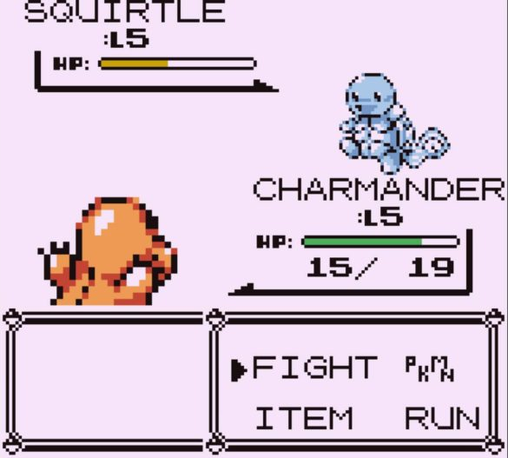
Pokémon Red/Blue/Yellow (1999)
Pokémon was originally released for the EU in 1999 on the Gameboy. It had a simplistic GUI, featuring your character moving around a world and entering battles with creatures called Pokémon, and other Pokémon trainers. This game was extremely successful, and this was mainly due to its gameplay experience over its graphics, which were dated even at its release. However, these simplistic graphics were said to be one of the game’s biggest draws, forcing people to use their imaginations, making it more engaging.

Features

Combat System
While the general gameplay of Pokémon is not something I will be incorporating as it’s very different from a text adventure’s, the combat system is similar. The player is given a list of options to pick from which each perform different actions. For example, it could be to attack the opponent, or perform a special move to give them more power on their next attack, etc. This is similar to a text adventure, except you are given the options instead of having to type them yourself.
In addition to this, Pokémon uses a chance-based combat system. This means that, depending on what random number is generated, the attack or defence will be more/less effective. These are both features that I would like to incorporate, as they make the game more complex and prevent the player from becoming quickly bored – having to come up with different tactics as they go. However, I will be adapting this feature by using a dice to determine the random number, and this will be visible to the player. As well, the player will have to type in their actions instead of selecting them from a list.

Graphics
During battles, Pokémon displays a standard battle screen. This screen follows the same format every time, only showing different characters and options. This screen is useful to the player as it is extremely user-friendly, showing them all the available options, as well as their health and the opponents health. It also allows the player to see the opponent they are battling instead of just reading a name or description. This can make it easier to convey the opponent – whether they are a cute Pokémon they should take pity on, or a frightening and challenging one.
I will not be incorporating this feature into my game as, while it would be a nice addition, I feel it does not follow the classic look and feel of a text adventure. In addition to this, I am not confident in my ability to create even pixel art versions of characters to an acceptable standard, while still spending enough time on the programming. However, I don’t think my game will lose too much from not including this feature as the descriptions of the characters will be comprehensive and the health will be visible after every move.

Limitations

Simple Commands
As opposed to games like Zork and The Hobbit, Space will only accept relatively simple commands, such as “pickup” and “use”. This is due to not having enough time to implement a more complex system into the program while still completing the game to an acceptable level.

Simple GUI
Space will use a very simple user interface, being a command line with the player’s health, a map, and a dice at the top. I will not be adding a more intricate interface into the game like in Pokémon or even The Hobbit as I prefer the look and feel of a plain UI – with one of the game’s main selling points being nostalgia for games like Zork. I also feel that the main focus of the game is on the story and adventure, not the UI.

Requires Java
As Space will be programmed and compiled in Java, any system that runs it will also need to have Java installed. Overall, this is an advantage for the players, as it means the game can be played on virtually any system (unlike C++, an alternative I considered, which would only be available on Windows systems). However, it also means the user must download both Java and the game, making it slightly more complicated to setup.

Linear Storyline
Similar to the majority of text-based adventure games, Space will mostly follow a linear storyline. This means that all the events (i.e. puzzles) will happen to the player in chronological order. While this makes the game easier to program, the downside is that the game becomes less replayable as all players will experience the same thing. The only deviations from this linear storyline will be the combat as it is chance based, therefore slightly changing the outcome for each player.

Requirements

Development

Java Development Kit (JDK)
As the game will be programmed in Java, any machines it is developed on will require a JDK installed. I will be using the latest long-term support version, which is 21. This means all machines it is developed on will also require this specific version.

Integrated Development Environment (IDE)
To develop the game, machines will also require a Java-compatible IDE. For Space, I will be using IntelliJ IDEA, as it is equipped with lots of functionality for preventing and locating bugs.

Operating System
According to IntelliJ IDEA’s system requirements, the oldest operating systems compatible are Microsoft Windows 10 1809 64-bit, macOS 12.0, and the two latest versions of Ubuntu LTS or Fedora Linux distributions that use Gnome or KDE, X Window System (X11), and GLIBC 2.29 or later.
Older versions and other operating systems will not be compatible with either some or all of the development tools, and therefore won’t be usable.

Random Access Memory (RAM)
According to IntelliJ IDEA’s system requirements, the minimum amount of RAM needed to run the software is 2 GB.
RAM is the primary storage of a computer, and is used to hold instructions and data for programs that are currently running. If the machine runs out of RAM, it will become very slow to use and can eventually crash.

Central Processing Unit (CPU)
According to IntelliJ IDEA’s system requirements, the minimum CPU needed to run the software is any modern CPU, but it strongly recommends a multi-core one as it supports multithreading.
A CPU handles all the instructions from programs and the computer. Each core is essentially another connected processor, and it allows programs that support multithreading to run instructions in parallel, making them much faster.

Secondary Storage
According to IntelliJ IDEA’s system requirements, the minimum amount of secondary storage needed to run the software is 3.5 GB.
Secondary storage is used to hold permanent data, such as software and files. In the development of Space, it will be used to store software files for both IntelliJ IDEA and the JDK, and the data for the game itself.

Mouse & Keyboard
During development, both a mouse and keyboard will be required. The keyboard will be used for writing the code for the game, and the mouse will be used for designing the GUI, as IntelliJ IDEA has a drag-and-drop designer.

Post-Development

Java
As Java is not installed on the majority of machines by default, anyone wanting to launch the game will also require java to be downloaded.

Operating System
According to Java 21’s system requirements, the oldest operating systems compatible are Windows 10, Ubuntu Linux 22.04 LTS, and macOS 11.
Older operating systems will not be compatible with Java 21, and therefore won’t be able to launch the game.

Random Access Memory (RAM)
As Space is a text-adventure using minimal graphics, and is programmed in Java – which is a relatively memory-efficient language – a machine would require less than 1 GB to comfortably run the game.
If the machine did not have enough RAM when running the game, then it could crash.

Central Processing Unit (CPU)
As Space is a text-adventure using minimal graphics, there aren’t many CPUs that won’t be able to run it. A CPU with multiple cores could be useful to run multithreaded processes, but there will not be many of these and the impact they will have will be minimal.

Secondary Storage
To launch the game, the machine will require both Java 21 and the game’s executable file installed. Combined, these will take up less than 1 GB, meaning it can be played on virtually any device.

Keyboard
As Space is a text-adventure, it is controlled by typing in commands to control your character. To do this, the player will require an English keyboard. A mouse will not be needed at all.

Success Criteria

#1 - Functional GUI

How will it be assessed?
If the game can be played fully through the GUI (somewhere to input commands, somewhere for the game to reply to commands, somewhere to see the room name, somewhere to see player health, and somewhere to see the map).

Justification
If the GUI is not functional, then aspects of the game will not be usable or function correctly, making the game less fun or even impossible to play.

#2 – Room descriptions

How will it be assessed?
If rooms are described correctly to the player, listing all items contained within it, and any items contained within them, and it is all formatted correctly.

Justification
Due to the large number of items that a room could contain, and also the items the items can contain, it could be difficult to output this all to the player effectively and correctly. If it is done incorrectly, it would be highly confusing to them and would make the game very difficult to play.

#3 – Good combat system

How will it be assessed?
Using a questionnaire.

Justification
As combat will be a large part of the game, it’s important that players find it fun and well balanced. If it is too easy, it won’t feel like a challenge. If it is too hard, players could get annoyed. If it’s not fun, players will get bored.

